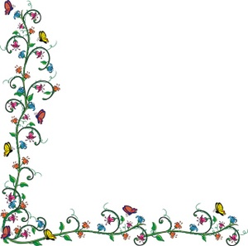
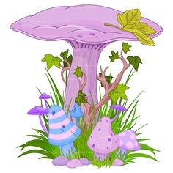
Create a Fairy Garden
- Choose a suitable container...large shallow plastic bowl, old enamel basin, small suitcase, old drawer or small wooden box, large basket...something with character. Keep it small enough to be easily transported...see note at bottom of page.
- If you have trouble getting started check on-line for images of fairy gardens or YouTube video how-to’s. There are tons of ideas!
- If you are keeping your fairy garden outside you need to have drainage holes in case of heavy rains. For wooden boxes or baskets you will need to line it with plastic such as a garbage bag. Don’t use garden soil as it will be too heavy.
- Choose a few plants that will stay small or are easily trimmed. Be sure that all your plants need the same growing conditions...dry, wet, sun, or shade. Succulents are great but can be pricey. Check your garden or a friend’s...with permission. Sedums, hens and chicks and moss work well. If using flowers look for tiny ones. You don’t need a lot of plants but it depends on your container. Try for at least one taller plant, something that will drape over the side of your container along with a bit of color.
- Check through your toy box or junk boxes in the house, garage, yard sales, thrift stores, etc. for tiny objects that you can use to create the setting. Tiny doll furniture, small birdhouses, gourds, buttons, or small containers.
- Try to use natural material. Look in nature for pine cones, acorns, stones, small sticks to create fences or furniture.
- Make trellises, seats, houses with popsicle sticks, logs, or willow...it will be hard to stop once you get started. Don’t make it too busy and try to keep the scale the same.
- If you are going away on holidays be sure someone is checking on your fairy garden to keep it watered...or take it along!
- Once you get started it will be hard to stop...make more than one and then pick your best to bring to the flower show! Or connect several and then bring just one piece. Have fun!
- Trim plants that get unruly or trade more appropriate plants as the season develops.
- The Beautiful Plains Horticultural Flower Show at the Legion on August 14. Enter your fairy garden in the show. Remove any dead plant parts. Clean it up a bit and add or remove anything that isn’t working. There are lots of things you could buy but originality and creativity along with plant health will be more important than how much you spend. It should be brought in the night before. Check for details at Beyond the Garden Gate closer to the date.

